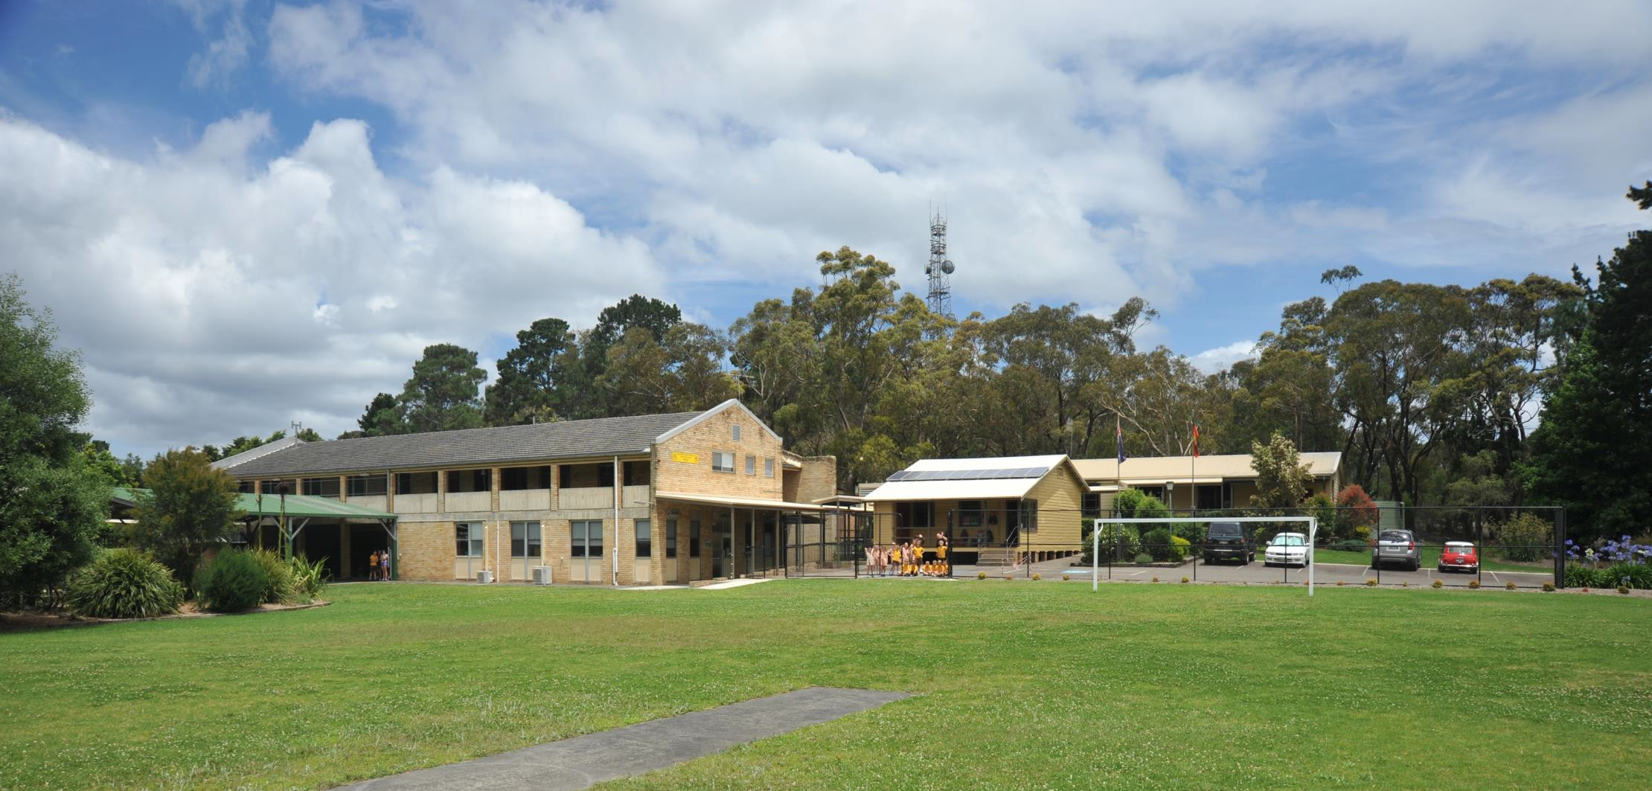
School plan 2015 – 2017
Somersby Public School – 3078 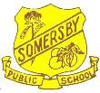

Planning template – V2.0 [11/11/14]

School background 2015 - 2017

School vision statement |  | School context |  | School planning process
Somersby Public School aims to develop active life- long learners through quality teaching and learning practices that are fostered through strong partnerships and connections.  Our PBL values of Respect, Responsibility and Excellence will be embedded in all that we do and seen as significant by all school community members. |  | Somersby Public School is located on the Somersby plateau and is a proud member of the Kariong Mountains Learning Community. The school provides education for students drawn predominantly from the surrounding rural area with an enrolment of 70, including 5 Aboriginal students.  The staff consists of a Teaching Principal, two full-time teachers and one temporary teacher, a Senior Administrative Manager; School Office Manager and a General Assistant who are highly dedicated, experienced and share a commitment to providing inclusive and innovative quality education  .  The school implements Language, Learning and Literacy (L3) and Targeted Early Numeracy (TEN). We have been a Positive Behaviour for Learning (PBL) school for three years and it will continue to play a vital role in student welfare in the future.  To facilitate student engagement and provide a well-rounded education for our students, our school provides a broad range of extracurricular learning experiences including our environment group, choir, dance group,debating, public speaking sport and the arts.  Somersby PS is committed to consolidating and strengthening links with the local and wider community. The school enjoys the support of an active P&C committee. |  | To assist the planning process, the following measures were implemented:  - During monthly P&C meetings discussions were held regarding the three strategic directions. A working party was established consisting of three parents to continue working on the plan.  - Surveys were conducted regarding community satisfaction, numeracy and student leadership  - Staff meetings were utilised to discuss directions and formalise the plan  - Professional learning (Strategic Planning/Data Analysis) was completed  - Data analysis of NAPLAN/Best Start/L3/PBL results were used to help drive future targets.  - LMG meetings were used to discuss commonalities within our schools and programs that were running across the LMG  Key DEC reforms were also considered, in particular Great Teaching Inspired Learning, The Melbourne Declaration and the new School Excellence Framework.

Somersby Public School - 3078
Page 2

Planning template – V2.0 [11/11/14]

STRATEGIC DIRECTION 1
Promote Quality Teaching and Learning

STRATEGIC DIRECTION 3
Promote and Enhance Strong Partnerships and Connections
Purpose: To build the capacity of teachers to deliver quality education to all students through the implementation of innovative and engaging programs.
Purpose: Fostering of quality, sustainable relationships throughout the school and wider community to maintain a positive, inclusive and successful school culture.
School strategic directions 2015 - 2017

Purpose: For all students to be actively involved in opportunities that support their development in becoming independent, life-long learners.

STRATEGIC DIRECTION 2
Develop Active, Informed and Creative Citizens

People

How do we develop the capabilities of our people to bring about transformation?

Students
Students will actively participate in a variety of learning programs aligned to current (and future) syllabus requirements.
Staff
- All staff to engage in professional learning in new syllabus requirements to ensure current teaching practices are embedded in their teaching and learning programs.
- Staff will differentiate teaching and learning activities to meet the needs of all, including G&T and learning needs students.
Parents/Carers
Develop clear understandings of current curriculum through regular communication and participate in forums/meetings to actively engage in their child’s education.
Community Partners
- Develop network partnerships with other schools for professional learning with a focus upon quality teaching practice and consistent teacher judgement.
- Schools in the LMG participate in combined curriculum projects eg writing, science.
Leaders
Ensure staff are given the opportunity to engage in quality professional learning and maintain well-resourced teaching and learning environments.
Strategic Direction 1: Promote Quality Teaching and Learning

Purpose
Why do we need this particular strategic direction and why is it important?

To build the capacity of teachers to deliver quality education to all students through the implementation of innovative and engaging programs.
Improvement Measures
- The proportion of students achieving Proficiency (top two bands) in NAPLAN in reading and numeracy to increase by 9%

- On the Literacy Continuum (Reading texts and Comprehension) students will achieve:
•Cluster 8 by the end of Year 2 •Cluster 9 by the end of Year 3 •Cluster 10 by the end of Year 4 •Cluster 11 by the end of Year 5

- All staff report a high level of satisfaction regarding staff professional learning.

- 100% of RAM equity funds for socio- economic background, English language proficiency, Aboriginal background and low adjustment for disability are expended to support these equity programs.

Processes |  | Products and Practices
How do we do it and how will we know?  Teaching and learning programs developed to address new syllabus requirements. These programs reviewed regularly through Performance Development Framework implementation.  L3 implemented into the Early Stage 1 and Stage 1 class.  ICT infrastructure to be enhanced to allowed for students to have greater access to technology.  PLAN data will be entered for each student and expected growth to be monitored.  Students achieving below expected outcomes to receive additional support through LAST program or the school’s Intensive Literacy and Numeracy programs.  Evaluation Plan  Plotting student achievement using the Literacy and Numeracy continuums.  Using Best Start and L3 data to closely monitor the progress of students in K-2.  Analysis of NAPLAN data for Years 3, 5 and 7 to determine future teaching and learning directions.  Participation of staff professional development tracked using MyPL and Staff Professional Learning Plans. |  | What is achieved and how do we measure?  Products  - 80% of students achieve expected growth in NAPLAN  - 100% of students tracked using PLAN  - 80% of students achieving expected benchmark levels in K-2.  - All staff report a high level of satisfaction regarding staff professional learning.  - 100% of RAM equity funds for socio- economic background, English language proficiency, Aboriginal background and low adjustment for disability are expended to support these equity programs.  What are our newly embedded practices and how are they integrated and in sync with our purpose?  Practices  High quality teaching and learning practices demonstrated and supported across the school through teaching and learning programs, assessment, PDF and improved learning outcomes.  ICT infrastructure improved to meet the needs of teachers and students who are engaging in meaningful and innovative programs.  Staff understanding and skills increased to effectively teach our Aboriginal students.

People

How do we develop the capabilities of our people to bring about transformation?

Students
Students will be actively involved in PBL lessons that will encourage and supprot them take responsibility for their social, emotional and scholastic behaviours.
They will engage in relationships that develop a respect for self, community and a cooperative society.

Staff will:
- participate in Tier 2 PBL hub training throughout 2015 to ensure current practices are effective
- participate in professional learning opportunities to develop skills in the performing arts.

Parents/Carers
- Families will understand the language and ethos of the school PBL program and will be supportive of this.
- Parents support and encourage participation of their children in the various performing arts programs offered at school.

Leaders
LMG Principals will work together to create opportunities for schools to work collaboratively together on combined activities.
Strategic Direction 2: Develop Active, Informed and Creative Citizens

Purpose
Why do we need this particular strategic direction and why is it important?

For all students to be actively involved in opportunities that support their development in becoming independent life-long learners.
Improvement Measures
- PBL data

- 100% of Year 5 students display appropriate qualities to become a School Leader

- Creative and Performing Arts participation

Processes |  | Products and Practices
How do we do it and how will we know?  - Ongoing professional learning in PBL to support Tier 1 implementation, while focusing on the introduction of Tier 2 learning. Ongoing data collection to monitor student progress and drive interventions.  - The Year 6 Leadership Policy to be reviewed at the end of the year by staff, students and parents to ensure it is developing students’ leadership abilities effectively.  - The school band will be encouraged and supported to provide opportunities for students to perform publicly and participate in combined schools workshops.  - Opportunities for students to participate in dance, choir and debating will be provided  - Peer tutoring in the form of a Buddy Reading Program will be implemented on a regular basis to provide opportunities for students to develop a life-long love of reading.  Evaluation Plan  - Regular feedback from students, staff and parents sought regarding satisfaction of school-based programs.  - Regular analysis of PBL data  - Success rate of Year 5 students attaining School Leader status. |  | What is achieved and how do we measure?  Products  - 80% of students achieve ‘outstanding’ level in PBL  - 100% of Year 5 students achieve School Leader status.  - Increase of 10% of students involved in the band.  Practices  School wide values and expectations are explicitly taught and identified by students through the PBL program.  A comprehensive creative arts program including dance, band, recorders and choir is provided for all students.  Participation in Aboriginal cultural education, in partnership with the local Aboriginal community and LMG schools is valued and supported.  LMG days will be promoted (Creative Arts days, NAIDOC Day and the KM LMG ‘Day of Excellence’) to ensure strong partnerships are maintained.

People

How do we develop the capabilities of our people to bring about transformation?

Students
- participate in a number of local events and see the value of these links to the wider community.

Staff
Staff will develop the capacity to build and maintain stronger community relations with parents and improve models of positive communication and consultation including reporting.

Parents/Carers
Parents understand the valuable contributions they make to school life and recognise the impact they have on the educational performance of their children through actively engaging with the school.

Community Partners
Local businesses and community group’s participation in school initiatives will help promote and foster quality community relationships.
Develop and strengthen links between The Kariong Mountains Local Management Group and the local Aboriginal Education Consultative Group.

Leaders
- Understand that strong connections with families and the community have a significantly positive impact on student learning and outcomes.
Strategic Direction 3: Strong and Effective Partnerships and Connections

Purpose
Why do we need this particular strategic direction and why is it important?

Fostering of quality, sustainable relationships throughout the school and wider community to maintain a positive and successful school culture.
Improvement Measures
- 75% of parents download the new School App

- Community surveys

- Increase in staff communication and links with the KM LMG

- School programs and initiatives.

Processes |  | Products and Practices
How do we do it and how will we know?  Our parents regularly access and utilise the  Skoolbag app and Facebook page.  Aboriginal students will participate in school based and Regional initiatives.  Participation of staff in collaborative LMG Science and Writing Projects.  Improve links with our Local Management and Aboriginal Education Consultative Group.  Evaluation Plan  - Evaluation of data from staff who participate in professional networks across the Kariong Mountains LMG.  - Monitoring of parent participation in school programs and initiatives  - Survey results of parent satisfaction regarding the usage and effectiveness of the school app. |  | What is achieved and how do we measure?  Products  - 75% of parents download the new School App  - Community survey shows an 80% satisfaction amongst parents  - 100% of staff contributing to Kariong Mountains LMG projects (writing/science)  - Increase in the number of parents and community members participating in school programs and initiatives from 2015 to 2017.  Practices  Open and ongoing communication to maintain a cohesive and effective school community.  Parent and community helpers participate in a variety of programs both in classrooms and around the school.  Parents and staff work together to enhance the school environment.  The school develops a strong link with the local Aboriginal Education Consultative Group.  Use of a variety of technologies as communication tools.

St11111"bJ' PllMic Schttl • 3013

P•tt 1

Pl•nnint \.mplt\ -\12.0 (11111114)

